Grade 7 Accelerated · Unit 6 · Thread B · Day 2  Interior and Exterior Angles of a Triangle  Question Bank - Additional 6.T2 ANSWER KEY | Name  Date  Period

Show your work. Circle your final answer.
For questions 1 through 4, find the angle.
1. The third angle of a triangle with angles of 29° and 88°
63°
180 − 117.

2. The third angle of a right triangle with an angle of 44°
46°
180 − 90 − 44.

3. The exterior angle whose remote interior angles are 33° and 79°
112°
33 + 79.

4. The other remote interior angle, when an exterior angle is 125° and one remote angle is 68°
57°
125 − 68.

For questions 5 through 7, find x and the angles.
5. A triangle's angles are 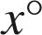, 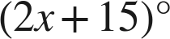 and 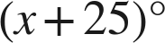.
x = 35; 35°, 85° and 60°
4x + 40 = 180.

6. An isosceles triangle's base angles are each  and the third angle is .
x = 15; 58° and 58°
8x − 4 + 64 = 180.

7. An exterior angle is 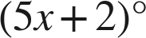; its remote interior angles are 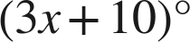 and .
x = 22; the exterior angle is 112°
2x = 44.

Choose one.
8. A triangle's angles are 25°, 65° and 90°. What is the exterior angle beside the 65°?
● A. 115°
○ B. 65°
○ C. 295°
○ D. 25°
A
25 + 90.

9. Which equation finds x when an exterior angle is 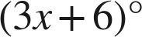 and its remote interior angles are 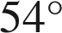 and 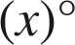?
○ A. 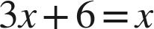
○ B. 
○ C.
● D. 
D
Outside equals the two far ones: x = 24.

